‘Yr Hen Dŷ Gwag’ – Adnodd y Dysgwr
- Edrychwch ar y geiriau o 1 - 10. Yna, o’r blwch, dewiswch y gair croes ei ystyr i bob gair a’i ysgrifennu wrth ei ymyl.
poeth/twym trefnus allan llawen/braf rhedeg
pawb yn agos llawn moethus distawrwydd

- gwag ...................................................
- diflas ...................................................
- oer ...................................................
- di-drefn ...................................................
- moel ...................................................
- neb ...................................................
- i mewn ...................................................
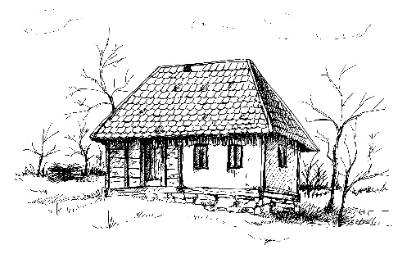
- cerdded ...................................................
- o draw ...................................................
- sŵn ...................................................

- Dewiswch 5 gair o’r rhestr neu o’r blwch a’u rhoi mewn brawddegau, un gair i bob brawddeg. Ceisiwch beidio â defnyddio’r geiriau ‘hawdd’, e.e. oer.

- .........................................................................................................................................
- .........................................................................................................................................
- .........................................................................................................................................
- .........................................................................................................................................
- .........................................................................................................................................

