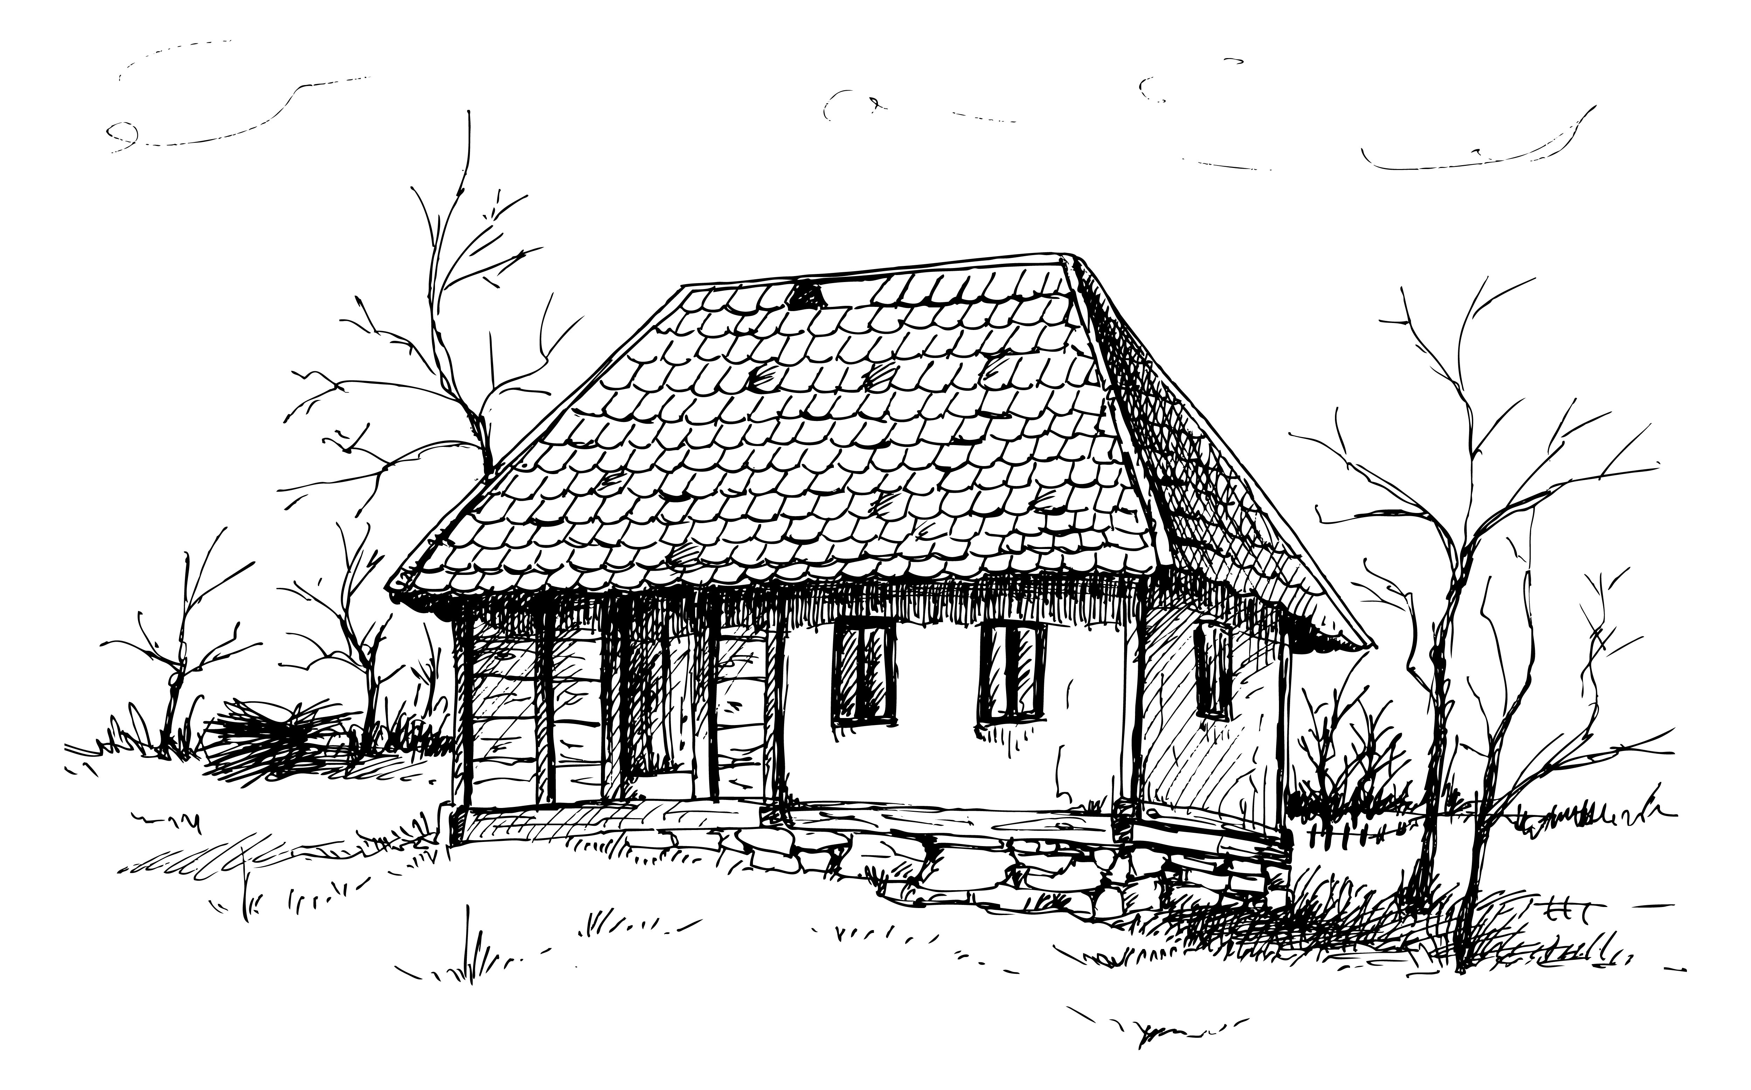

Pwy oedd yn arfer byw yn yr Hen Dŷ Gwag?

_____________________________________________________________________________________________________________________________________________________________________________________________________________________________________________________________________________________________________________________________________________________________________________________________________________________________________________________________________________________________________________________________________________________________________________________________________________________________________________________________________________________________________