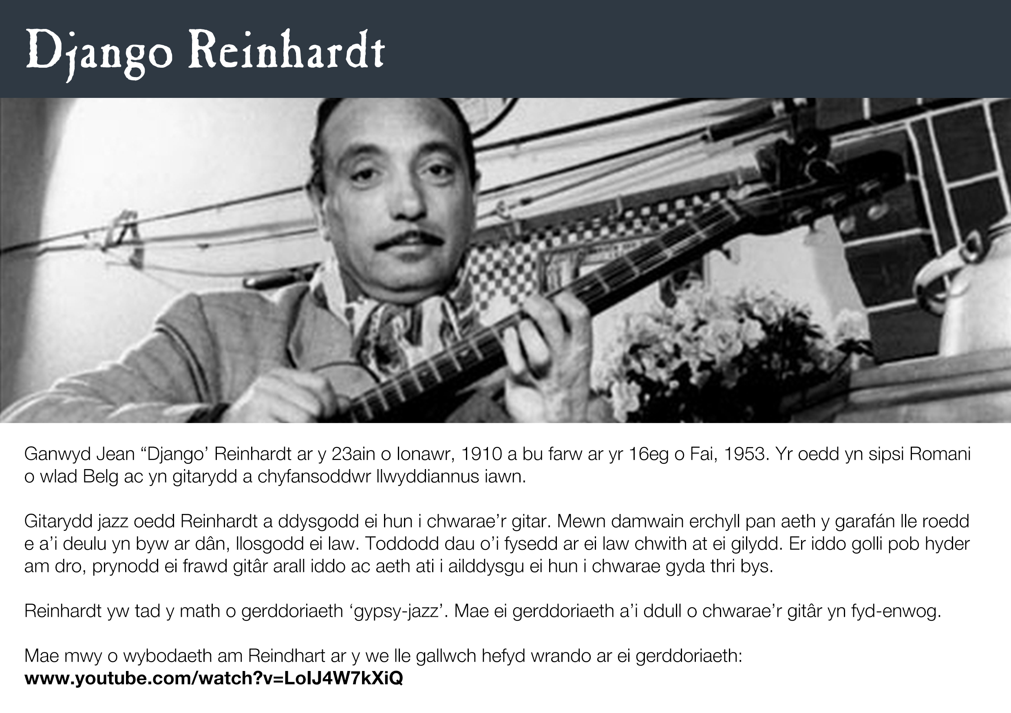

Dolenni posib……

<https://www.youtube.com/watch?v=PQhTpgicdx4>

<https://www.youtube.com/watch?v=Cz01elysL0E>

<http://www.biography.com/people/django-reinhardt-9454889>